DBMS LAB MANUAL

Name: NEHA K Roll.No: 230701209

**Creating Views**

**Ex.No.5:**

1.CREATE VIEW EMPLOYEE_VU AS SELECT Eno,Ename,Deptno from EMPLOYEE;

2. SELECT *FROM EMPLOYEE_VU;

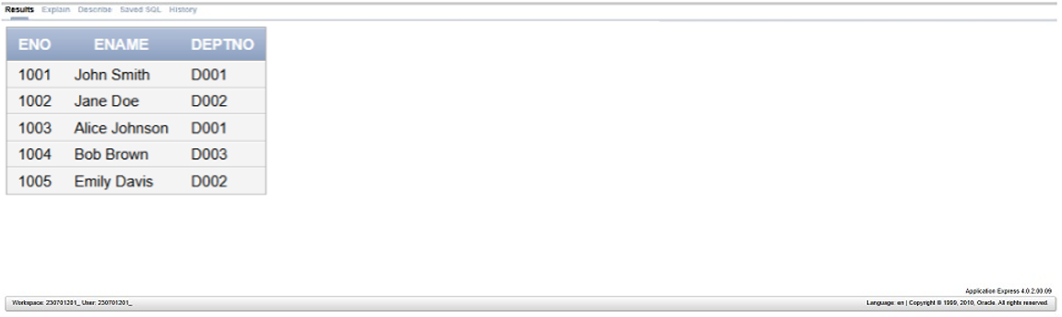

3. SELECT *FROM USER_VIEWS;

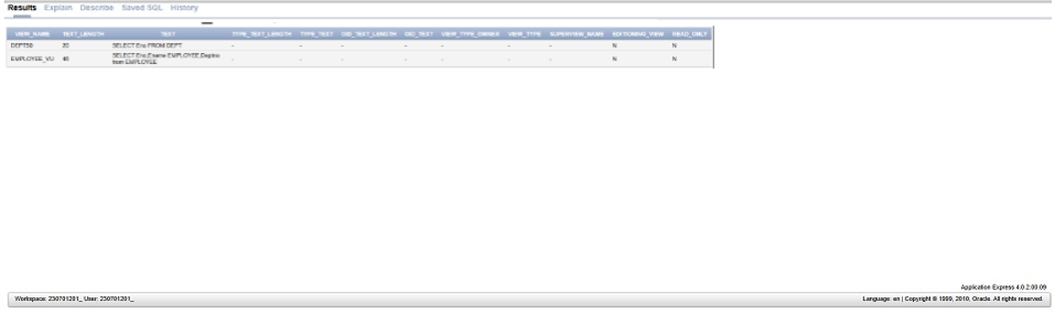

4. SELECT EMPLOYEE, DEPTNO FROM EMPLOYEE_VU;

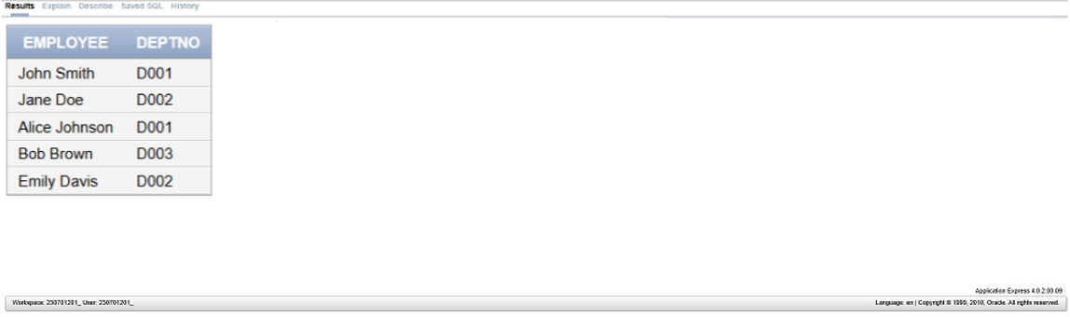

5. CREATE OR REPLACE VIEW DEPT50 AS SELECT ID EMPNO, NAME

EMPLOYEE, DEPTNO FROM DEPT where DEPTNO=50 WITH CHECK OPTION

CONSTRAINT DEPT50_ck;

6. desc DEPT50;

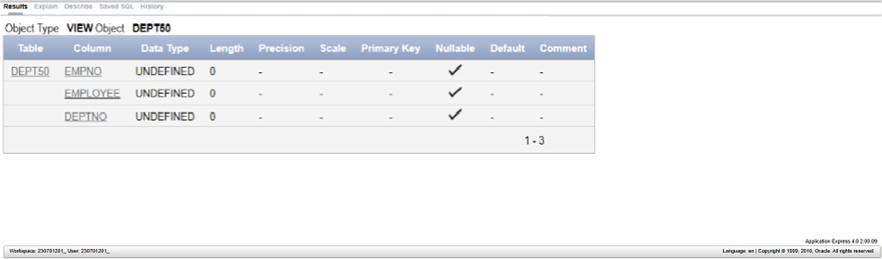

7. SELECT *FROM DEPT WHERE NAME=’Matos’ where DEPTNO=80;

This updates the value in both Main and view table (if created).

8. CREATE OR REPLACE VIEW SALARY_VU AS SELECT LAST_NAME

EMPLOYEE, DEPT_NAME DEPARTMENTS,SAL SALARY, GRADE_LEVEL

GRADE FROM EMPL,DEPARTMENT,JOB_GRADE;